Evidence for Analysis and Design Unit

Ross Hill

Cohort E18

**A.D. 1 – Use Case Diagram**

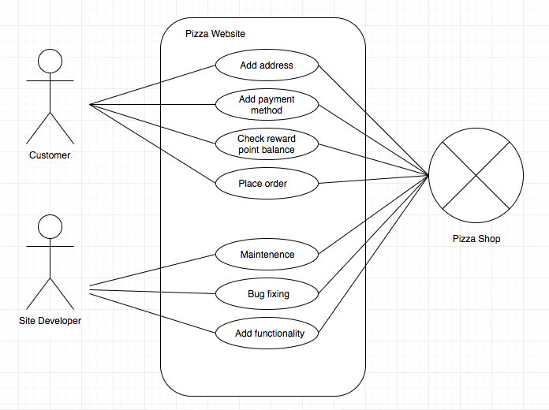

**A.D. 2 – Class Diagram**

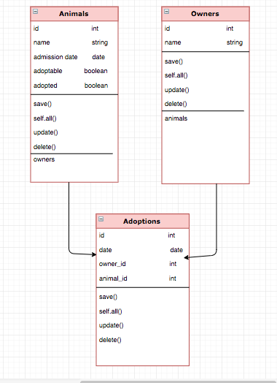

**A.D. 3 – Object Diagram**

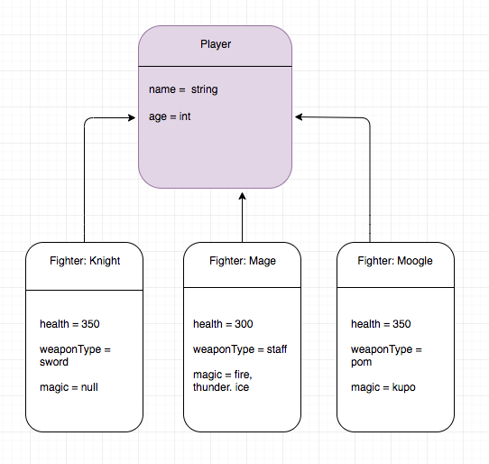

**A.D. 4 – Activity Diagram**

**A.D. 5 – Inheritance Diagram**

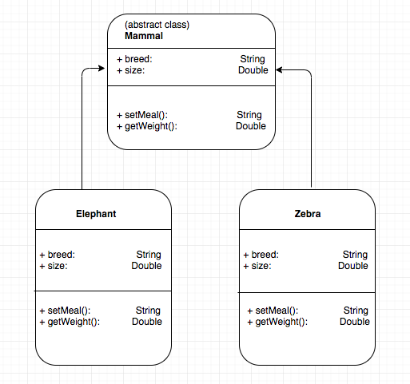

**A.D. 6 – Implementations Constraint**

|  |  |  |
| --- | --- | --- |
| Topic | Possible constraint on product | Solution |
| Hardware and software platforms | **App may not be compatible with every Android device** | **Select an Android OS that the vast majority of users are running or able to run.** |
| Performance requirements | **Animations may cause app to run slowly on certain devices** | **Limit or remove any animation effects in the app** |
| Persistent storage and transactions | **Accessing storage may take time, especially in the case of accessing SD card storage** | **Store only the necessary data required for functionality. Give option to delete high score data** |
| Usability | **Images may not load, or may load incorrectly** | **Use alt text to describe the images in the case of images not loading.** |
| Budgets | **Limited budget as app is being developed independently. This could mean certain features are missing.** | **Make app open source so others are able to contribute features.** |
| Time | **Product must be completed by a strict deadline** | **Plan accordingly so that core features are implemented, and less important features only if time permits.** |